SUBSIDIARY ICT PAPER ONE GUIDE 2013

- (a) Define Information and Communication Technology (1mark)
Refers to the combination of telecommunication and computing technologies to enhance communication

IT relates to all means, which facilitates information or data capture, processing, storage, and communication or output

(b) Assuming, you have been appointed as the head of ICT department in your school. The school wishes to buy new computers to ease the work of teaching and learning ICT.
Explain four factors you would consider when buying computers.
(4 marks)

- Needs of the organization or volume of transactions.
- System specifications e.g., capacity of HDD, RAM, processor speeds, and system board architecture (closed Vs. Open, Single vs. Double layered), monitor resolutions, accessories, etc.
- Nature of the Institution\Business
- Safety provision, fatigue plus stress, Noise
- Costs of system components and development.
- Initial cost outlay.
- Installation costs
- Maintenance and repair costs.
- Personnel costs.
- Source of system components
  - Environmental concerns. A good system must be
environmentally friendly.
  - Available employee skills.

- Explain one specialised application ICTs can play in each of the following areas (5 marks)

- Education
Many Universities, Colleges, school and public libraries are on line with websites for purposes of making easy access to educational information..
Education references soft ware e.g. the Infopedia, Encarta, etc are programs used for helping people with English usage, data collection and analysis

- Health

    - Medical tests for instance blood, cancer, Brain damage etc
    - Carrying out sensitive operations on sensitive body parts like the brain, heart, kidney, etc.
    - Drug mixing and prescriptions.

- Entertainment
lots of leisure and entertainment activities in form of;
    - Computer games
    - Computer audio music and video players
    - Games on line
    - Leisure centers on line.
    - Leisure websites
Skynet.com for sports and manu.com, are some of the informative leisure websites.

- Security
IT Laser guided cameras and satellites are now used for national and domestic security. Business like Banks, supermarkets etc also use IT Laser guided cameras for customer monitoring in the business hall.
Information technologies are also used in the military to fly and direct combat planes, locate enemy positions and hit/shell them with minimal civilian and property losses.

- Industries

In many large manufacturing and production processes robots are being used to handle tasks, which cannot be efficiently handled by humans.
Computer Aided Design (CAD) and CAM (Computer Aided Manufacture) are also in this category.

- Bridget is a lab assistant in kibisi sec school. She was requested to present a list of items she would use in her computer lab. Among the items she listed included a blower, antiglare screens, computer covers, air conditioners and surge protector.
Explain the importance of the each of the following ( 5 marks)

- Blower
Used to remove dust from computer system

- Antiglare screens
Regulates excess light from monitor

- Water proof covers
Protects computers from dust and water

- Gaseous fire extinguisher
It used to put off fire

- Surge protector
Regulates power voltage to the required levels required by computer sytem

- (a) In reference to the following file path: C/user/desktop/Abu/letter.doc. identify the following, (2marks)
- File name: letter
- File type: document
- Profile: user
- Folder: Abu
- Location: C://

- Give the file extension of the following file types. ( 5 marks)

File type file extension

- Ms Word .doc
- Batch file .bat
- Executable file .exe
- Text file .txt
- Ms Excel xls

- (a) Define peripheral devices (2marks)

Peripheral device refers to external hardware that is connected to a computer motherboard using data interface cables through ports

(b) A student wishes to store data on optical storage medium.
i) List down one optical storage medium (1 mark)
Compact disk, DVD, VCD
ii) Give one advantage of optical storage you have mentioned in b (i) above (1 mark)
Has higher storage capacity than floppy diskettes
Portable in size
iii) Give one disadvantage of optical storage you have mentioned in b (i) above (1 mark)
Small scratch can make a whole c.d useless.

7. a) What is a hardware device? ( 2 marks)
Refers to the physical components of a computer system. They are components which can be seen, touched or felt.

b) State one function of each of the following components of the computer central processing unit ( 3 marks)
(i) The control unit (CU)
- Interprets commands i.e. it’s is the intermediary between the user and the computer.
- Controls and times all tasks by the CPU (typical of
Multi-tasking where processor time is shared amongst.

(ii) The arithmetic/logic unit (ALU),
  - . works on data to be subjected to mathematical operations/calculations and logic. Arithmetic involves fundamental math operations of -, +,*, /, etc.
Logical Operations involve comparison of phenomena e.g. passed/failed, yes or no, present or absent, =, >, <, on/of, etc.

(iii) The Registers
Are additional storage locations in the CPU which hold data and instructions temporarily during processing?

8. Name the devices A, B, C , D and E using the words from the list.

A B


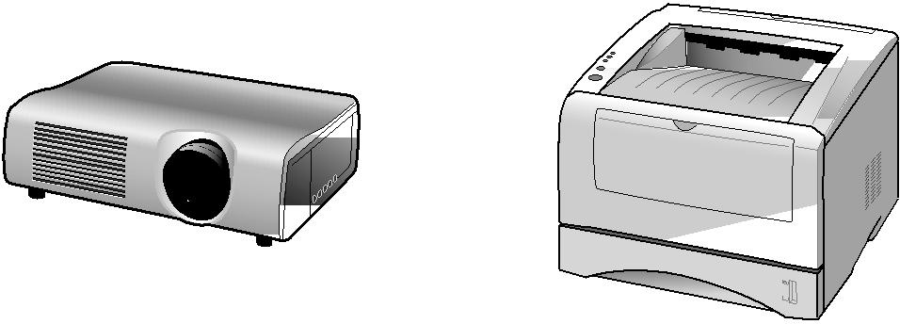
C D E
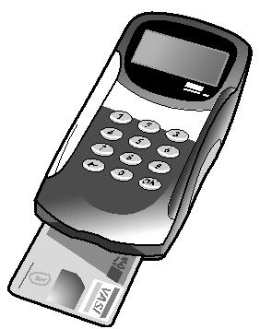

Data projector | Digital camera | Joystick | Laser printer
Microphone | Remote control | Scanner | Track ball
A trackball |  | B scanner
C Remote control. |  | D data projector

E laser printer

9. Complete each sentence seen below using one item from list;
Compilers Interpreters linkers
Basic Cobol Custom software
Freeware Publication Packaged software

a) Packaged software is a commercial software which is copyrighted and designed to meet the needs of many users. ( 1 mark)

b) Freeware is software provided at no cost to users. (1 mark)

c) is software developed at a user request to perform specific function. (1 mark)

d) Custom software Is software that translates the source program line by line while the program is running. (1 mark)

e) Basic is software that is used to teach junior programmers. (1 mark)

10. (a) What is operating system? (2 marks)
An operating system is a master control program which manages and supports the operations of the computer system. Operating systems contribute to the control and management of the computer system. E.g. Window 98, NT, 2000

(b)Explain any three functions of operating systems (3marks)

- Booting
- Managing storage media/files
- of computer resources.
- Managing tasks and processes
- Providing User Interface
- Provision of the platform for application software to run

11. A student in school X was asked to format a flash disk in windows based operating system. The student instead formatted the hard disk by mistake.

(a) Explain the term formatting a disk ( 2 marks)

Formatting is the process through which the operating system creates sectors and tracks on the disk and deletes any data on the disk so as to prepare a disk for use and enable the operating system to recognise and access disk

(b) State three situations when the computer user will be required to format a disk (3 marks)
- When it contains unwanted files
- When files are corrupted by virus
- To enable the operating system recognise and access the disk
- When the disk is full and the user would want to store new data

12. Study the URL and answer the questions that follow:
http://www.ecdl.org/countries/uganda

(i) What does http stands for? (1 Mark)
Hyper text transmission protocol
(ii) The domain name is (1 Mark)

www.ecdl.org/countries/uganda.html
(iii) Which is the top-level domain (TLD) in this URL? (1 Mark)

org
(iv) What does “countries” represent in this URL? (1 Mark)
The path

………………………………………………………………………………………….
(V) What is the document name which is currently opened on this website? (1 Mark)
uganda

13. Today internet is becoming almost part of man’s life. State any five positive effects of internet to the society. (5 marks)

- Offers personnel connectivity for friends and financiers through E- mails, E–collaboration and chat – rooms, online telephone calls, voice mails, video phones, etc
- It is a tool for entertainment through on–line games, clubs and interactive games, online chats, refreshing video clips (movies) and animals’ zoos.
- It is a source of important electronic programs/applications through downloading of freeware, shareware and other programs.
- Offer travel services like E-Booking and reservations for aviation firms and hotels, to business travellers and holidaymakers.
14. a) a) explain the term Domain Name system (1 mark)
Is the system on the internet that stores the domain names and their corresponding IP addresses?

An e-mail address is given as lubakyoya@gmail.com, identify each part of this address. (4marks)

- Lubakyoya : name of recipients
- @ : is the symbol that separates the email user name from the rest of the address
- Gmail: is the name of the domain where the e – mail account is held
- .com: is the type of the domain where the email accounts is held. in this case the type of e – mail is held in a commercial domain.

15. (a) Define the concept of data communication ( 1 mark)
This refers to one computer transferring data, instructions and information to another computer or some other computers.
(b) Explain the function of the each of the following in relation to data communication

a) Sending device ( 1 mark)
Initiates an instruction to transmit data, instruction or information e.g computer A which sends signals to another computer B
b) Communication device ( 1 mark)
Converts data ,instructions or information from the sending device into signals that can be carried by a communications channel e.g Modem which converts digital signals into analog signals.

c) Communication channel ( 1 mark)
path over which signals are sent e.g a standard telephone line along which the analog signals are sent.

d) Receiving device ( 1 mak)
Computer B that accepts the signals from computer A.

16. Mobile telephones are used for accessing internet

- Give three advantages of using mobile telephones for internet access.( 3 marks)
- Usually have mobile phone in your possession
- Easy to carry/are portable
- its cheaper to access internet using phones

- Give two disadvantages of using mobile telephones for internet access. ( 2 marks) - Easily lost
- May have poorer signal

17. ( a) define the term firewall as used in computing? ( 2 marks)

Fire is part of computer system of network that is designed to block unauthorised access while permitting authorised traffic.
Or
A hardware or software installed on a computer that filters the information coming through internet or local area network(LAN)

(b) Mention any three forms of unauthorised access ( 3 marks)
- hacking
- Sabotage
- Surveillance
- cracking
- Phishing
18. a) Briefly describe the concept of “green computing” ( 2 marks)

Green computing refers to the use of computers and other ICTs in an environmentally responsible and eco- friendly manner

(b) State any three advantages of green computing (2 marks)
- preserves natural the environment
- minimize costs
- maximize energy efficiency

19. The following is a mark sheet of senior four ngoma secondary school.

 | A | B | C | D | E
1 | NAMES | History | ICT | chemistry | art
2 | kabanda | 45 | 67 | 76 | 89
3 | kainembabazi | 34 | 45 | 56 | 48
4 | Awori | 67 | 65 | 76 | 78
5 | Mwondha | 98 | 56 | 45 | 59
6 | Nyakato | 45 | 90 | 67 | 67

- Write a formula to calculate the following ( 3 marks)

- Total marks for Kabanda. =SUM(B2:E2)

- Average score for Awori: =AVERAGE(B4:E4)

- The highest score for Nyakato = MAX(B6:E6)

- Write a formula to count all the ICT students with marks greater than 60. ( 2 marks)
=COUNTIF (C2:C6,”>60”)
20. Lady Aisha book library uses a database to store information about the different books they have. Part of database is shown below.

Book Title | Number of books borrowed | Nature of the book cover Hard or Soft
Introduction to biology | 56 | Yes
Dictionaries | 52 | No
Uganda constitution | 38 | No
Encyclopedia | 35 | Yes

- (i) Which field in the table above stores Boolean data type? ( 1 mark)

Nature of the book covers Hard or Software

(ii)Give a reason Why Boolean data type is used ( 1 mark)

Because it holds value that is either true or false
- (i)Which field stores numeric data? ( 1 mark)
Number of books borrowed.

(ii) Give a reason Why Numeric data type is used ( 1 mark)

holds numbers only
- Suggest one other data type used in the database above. ( 1 mark)

text

END

